CS 255 Business Requirements Document Template

Complete this template by replacing the bracketed text with the relevant information.

This template lays out all the different sections that you need to complete for Project One. Each section has guiding questions to prompt your thinking. These questions are meant to guide your initial responses to each area. You are encouraged to go beyond these questions using what you have learned in your readings. You will need to continually reference the interview transcript as you work to make sure that you are addressing your client's needs. There is no required length for the final document. Instead, the goal is to complete each section based on your client's needs.

Tip: You should respond in a bulleted list for each section. This will make your thoughts easier to reference when you move into the design phase for Project Two. One starter bullet has been provided for you in each section, but you will need to add more.

System Components and Design

Purpose
What is the purpose of this project? Who is the client and what do they want their system to be able to do?
- The client, DriverPass, wants to develop and release a new product to capitalize on a gap in the market for driving training for their local DMV. The system should provide an interface for users to schedule lessons, access DMV resources, and take practice tests.

System Background
What does DriverPass want the system to do? What is the problem they want to fix? What are the different components needed for this system?
- The system specifically should be a site accessible via a web browser. The site needs backups and security, and the project scope suggests it will be built and maintained using a cloud service provider to simplify updates and maintenance. The system will also have a public-facing side, a connection with the DMV, and an internal business side to function. The system must also comply with credit card, state, and federal consumer protection regulations when it goes into production.

Objectives and Goals
What should this system be able to do when it is completed? What measurable tasks need to be included in the system design to achieve this?
- The system should allow an administrative user to upload or create modules and activate or deactivate them. It should allow a user to create an account and log in to schedule sessions. A user should be able to adjust their chosen package and upgrade or downgrade at will. Information is available to users. The site can also provide DMV-linked resources and practice questions. The site should also adjust available cars, appointment slots, and trainers based on internal business databases.

Requirements

Nonfunctional Requirements
In this section, you will detail the different nonfunctional requirements for the DriverPass system. You will need to think about the different things that the system needs to function properly.

Performance Requirements
What environments (web-based, application, etc.) does this system need to run in? How fast should the system run? How often should the system be updated?
- The site should be accessible anywhere online via its web address
- Users will need to download a copy of reports and logs
- Users should be able to make reservations and adjust schedules as necessary
- A testing mechanism for practice tests online

Platform Constraints
What platforms (Windows, Unix, etc.) should the system run on? Does the back end require any tools, such as a database, to support this application?
- Accessible from any computer OS or mobile device via a web browser.
- The server should be hosted on a cloud provider's web server instance to offset maintenance concerns.
- An internal connection to the DriverPass database for scheduling and resource tracking
- A connection to the local DMV for information and regulation updates

Accuracy and Precision
How will you distinguish between different users? Is the input case-sensitive? When should the system inform the admin of a problem?
- Activity tracking based on user ID for actions and reservations
- Ability to print a report of logs for admins

Adaptability
Can you make changes to the user (add/remove/modify) without changing code? How will the system adapt to platform updates? What type of access does the IT admin need?
- Administrators and staff should be able to update site resources
- Provided services should be able to be added, removed, and modified by staff accounts
- Administrators should be able to see in the logs who made changes and have a report available for download

Security
What is required for the user to log in? How can you secure the connection or the data exchange between the client and the server? What should happen to the account if there is a "brute force" hacking attempt? What happens if the user forgets their password?
- Different roles based on logon
- A password reset feature for users
- Account disabling for people who leave the company and available for the Administrators to use

Functional Requirements
Using the information from the scenario, think about the different functions the system needs to provide. Each of your bullets should start with "The system shall . . ." For example, one functional requirement might be, "The system shall validate user credentials when logging in."
- The system must authenticate users, especially administrators and staff.
- The system should validate and sanitize user input as much as possible for security.
- The system needs to notify participating parties of schedule changes so staff and students know when classes change.

User Interface
What are the needs of the interface? Who are the different users for this interface? What will each user need to be able to do through the interface? How will the user interact with the interface (mobile, browser, etc.)?
- The main user interface should show the Logo, User information, driver notes, driver photo, student photo, and online test progress. Test progress should include tests taken, name, time taken, score, and status. Status could be not taken, in progress, failed, or passed. Driver notes should have comments the driver left and times for lessons in a table with columns "Lesson Time", "Start Hour", "End Hour", and "Driver Comments". Include an input form for the student or secretary to enter information, plus a page for contacting the school and student.

Assumptions
What things were not specifically addressed in your design above? What assumptions are you making in your design about the users or the technology they have?
- Since the client does not want to handle software updates or maintain backend servers, there may be a gap in technical expertise, so less complex solutions should be suggested and used instead of niche tools.

Limitations
Any system you build will naturally have limitations. What limitations do you see in your system design? What limitations do you have as far as resources, time, budget, or technology?
- Time: The project is expected to last 3.5 months from start to sign-off.
- Budget: Not mentioned, but likely a small organization
- Technical: The project focuses on providing a website that can meet the client's needs and will likely be hosted on a cloud provider, so the backend database and hosted site will need to be built in a way that allows user data and financial compliance checks to pass. The site should also be built to allow easy transfer to self-hosting or another cloud provider in case of pricing adjustments or changes to the provider's available services.

Gantt Chart
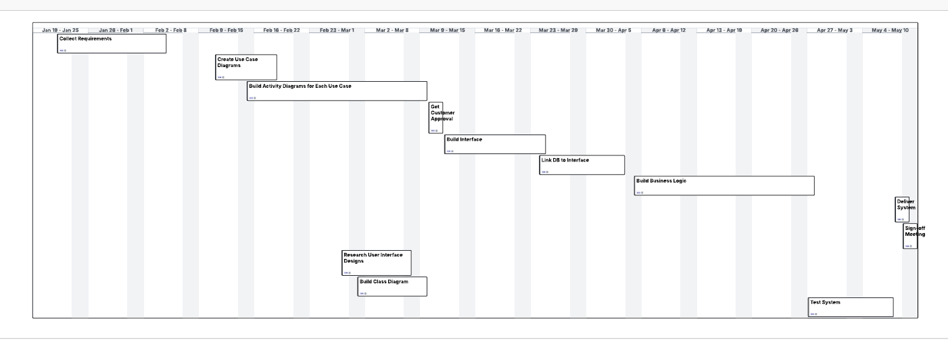
Please include a screenshot of the GANTT chart that you created with Lucidchart. Be sure to check that it meets the plan described by the characters in the interview.

